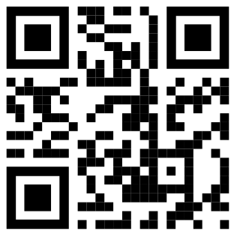
Thank you for ordering your
bGeigieZen Cadle Safecast.

Prepared and packed by:
Name :Rob Oudendijk
Date :2025-03-04

